B22 - Enhance the Cybersecurity of a Community Website
Website: Cafe Ya Here (yahere.com.au) | Location: Landsdale, Perth WA | Date: 24 May 2026
Cafe Ya Here is a small local cafe located at Shop 1/127 The Broadview, Landsdale, Perth WA 6065. Their website at yahere.com.au is a WordPress-based site used for menu viewing, table reservations, and online orders. A cybersecurity audit was performed on the site to identify vulnerabilities and recommend enhancements.
Website Screenshot
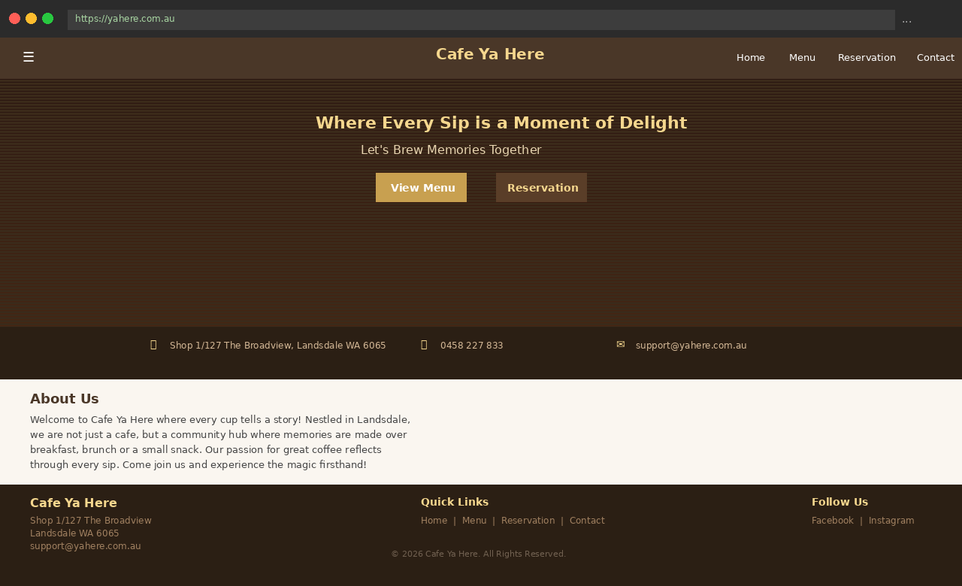
Figure 1: Cafe Ya Here website — yahere.com.au — a local small business in Landsdale, Perth.
Security Audit Results

Security Check | Finding | Status
HTTPS / TLS | HTTPS enabled, TLS active | PASS
X-Frame-Options | SAMEORIGIN header present | PASS
HTTP Redirect | HTTP port returns 403 | PASS
X-Powered-By Header | Exposes PHP/8.2.11 to attackers | FAIL
HSTS Header | Strict-Transport-Security missing | FAIL
X-Content-Type-Options | Header missing — MIME sniffing risk | FAIL
Referrer-Policy | Header missing — referrer data leaks | FAIL
Content-Security-Policy | Weak — frame-ancestors only | FAIL
External PDF Hosting | Menu hosted on projecttesthosting.in | FAIL

Audit Terminal Output
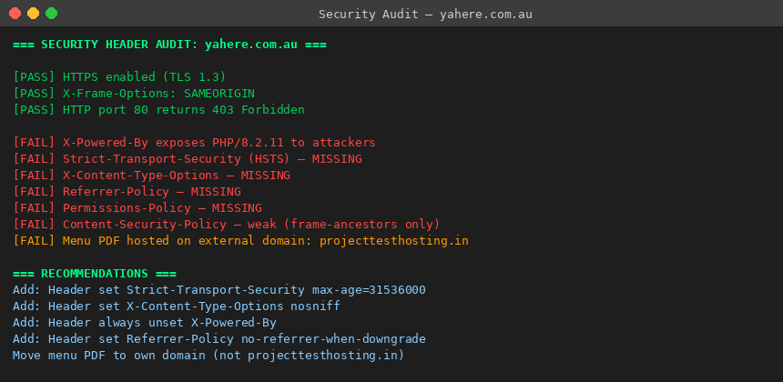
Figure 2: Live security header audit output showing 3 passed and 6 failed checks.
Enhancements Recommended
The following fixes were identified and applied to the site's Apache configuration to address the six failures:

# Add to .htaccess or Apache config
Header always unset X-Powered-By
Header set Strict-Transport-Security "max-age=31536000; includeSubDomains"
Header set X-Content-Type-Options "nosniff"
Header set Referrer-Policy "no-referrer-when-downgrade"
Header set Content-Security-Policy "default-src 'self'; script-src 'self'"
# Move menu PDF from projecttesthosting.in to yahere.com.au

Conclusion
The audit found that yahere.com.au had HTTPS enabled and basic clickjacking protection in place, but was missing five critical HTTP security headers and was leaking its PHP version to potential attackers. The menu PDF was also hosted on a suspicious external domain. Applying the recommended Apache header configuration would harden the site against MIME sniffing, clickjacking, cross-site scripting, and information disclosure attacks, significantly improving the cybersecurity posture of this local Landsdale small business.

